**Optimal Pairing of Forest Elements for Effective Man-Made Forests**

Aquino, Kurt Neil

De La Salle University, Manila

254 Sitio Bagong Anyo, Pagsawitan, Santa Cruz, Laguna

(+63) 9273597974

kurt_aquino@dlsu.edu.ph

Choy, Matthew Seaver

De La Salle University, Manila

109 Speaker Perez St., Quezon City

(+63) 9271273470

matthew_seaver@dlsu.edu.ph

Matias, Angelo Christian

De La Salle University, Manila

Villa San Pedro,

Magsaysay, San Pedro,

Laguna

(+63) 9277655527

angelo_matias@dlsu.edu.ph

1. **INTRODUCTION**

With the increasing pace of globalization and the advancement of technology, industrialization and urbanization has caused the decrease of the amount of forest lands in the world due to various reasons such as illegal logging and the overall increase in demand of commodities and resources. In order to balance this out, many countries have been opting out to repopulate these forests. This process of repopulating is called “reforestation”.

Goltenboth (1999) discusses that the process of reforestation is not just simply the replanting of trees, but instead should be a sustainable farming system used as a strategy for the restoration of a forest with the use of native or indigenous tree species, combined with agricultural crops. The objective of reforestation is to recreate an ecosystem as close as possible to the original state of a forest with regards to both its biodiversity as well as physical structure.

The objective of reforestation goes hand in hand with David Holmgren and Bill Mollison’s (2011) discussion of the ideologies of Permanent Agriculture or “Permaculture” for short, which is the development of agricultural ecosystems intended to be sustainable and self-sufficient. While considering the intent of reforestation, applying permaculture principles to reforestation processes and methodologies further reduces environmental degradation and ensures sustainability (Hutter, Goltenboth and Hanssler, 2003).

The Philippines, however, have only been using Narra and foreign exotic species in their efforts for repopulating forests (Milan and Calomot, 1994). The problem with this method of reforestation or creating man-made forests is that not all of the types of trees being planted go well with one another in terms of establishing a self-sustaining natural forest as it also disturbs its original and natural ecosystem.

1. **RESEARCH OBJECTIVES**

The general objective of this project is to analyze the problems brought about by the current methodologies of reforestation, propose a possible solution, and finally implement the proposed solution.

The specific objectives of this research are as follows:

To determine and analyze the impact of deforestation on students, homeowners, and related experts with regards to their experience and knowledge in agriculture.

* To assess the current process of reforestation in the Philippines.
* To identify the potential problems with the current process of reforestation in the Philippines.
* To propose a possible solution(s) to the identified problems based on existing related literature.
* To implement the proposed solution through the development of an application that would help solve the current problem

1. **PROPOSED SOLUTION**

Considering that the research group is undertaking courses under Computer Studies, the group is more inclined to research about the proposal of developing an application. This specific proposal aims to match together certain types of trees/plants that are needed to be replanted within a certain location in order to ensure local biodiversity as well as to pair them with other optimal agricultural crops as according “Companion Planting” guides, which are discussed in permaculture studies, in order to create a sustainable environment.

The proposal aims to design an application in which it accepts the number of trees/plants that the user would like to plant within a given location as well as the types of trees/plants that natively grows within the area. The application will then recommend the optimal positioning of the trees/plants on the lot by presenting them as a graph. This proposal can be applied for both forestry/forest repopulation as well as for agriculture/farming purposes.

1. **RESEARCH METHODOLOGY**

For this research topic, the group has consulted with experts within both fields of agriculture and computer studies and has asked for the opinion and views of the public (students, homeowners, etc.) with regards to the discussion of the problem statement and the proposed solution as according to their personal background as well as their experience with agriculture, or their lack thereof. For the agriculture expert, the group focused on gathering information with regards to the current processes of reforestation and the application of permaculture principles within their methodologies. For the computer studies expert, the group has discussed the feasibility and the effectiveness of the proposed application with regards to addressing the problem statement.

The research procedure was conducted in the following sequential manner: the gathering of the initial knowledge with regards to information about reforestation methodologies and its problems from the agriculture experts in the form of an interview; the definition of the statement of the problem as according the initial discussion with the agriculture experts; the brainstorming of possible solutions with regards to the defined problem statement with respect to the research group’s background and experience regarding the subject matter; The validation of the feasibility of the proposed solution to the computer studies experts in the form of an interview; The assessment and evaluation of the proposed solution by the agriculture expert; The gathering of demographic data from the target audience and respondents in the form of a survey; And finally, the implementation of the proposed solution.

1. **RESULTS**

As for the demographics of the research topic, the group was able to gather a total of 60 respondents for the surveys, with 37 (62%) being students, 16 (27%) being homeowners, and 7 (11%) listed under others. Only 13 (27%) of the respondents had any background in agriculture and only 2 of those 13 respondents had experience in planting their own garden (0.03% of the total) as shown in Figure 1.1. Among those who had experience in planting, both were homeowners. This gives the group the idea that despite some of the student respondents having some background with agriculture, they had no plans on planting their own gardens due to the inconvenience and effort it entails which will be discussed in the results later.

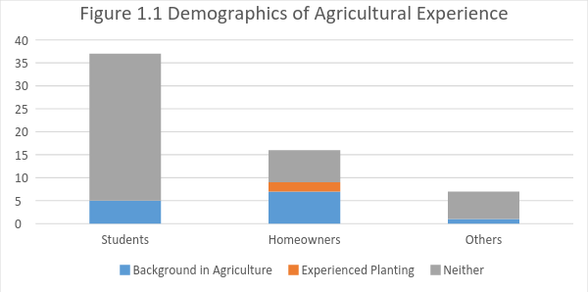

All of the respondents are aware that deforestation is an existing problem within today’s society and that reforestation is an effective way to address the problem. 47 (78%) respondents agreed that multiple species should be planted as compared to the 9 (15%) who suggested that only a single species of plants should be planted during reforestations and 4 (7%) respondents were unsure. This further clarifies which respondents have a background in agriculture as the diversification of a forest is key to ensuring a sustainable ecosystem.

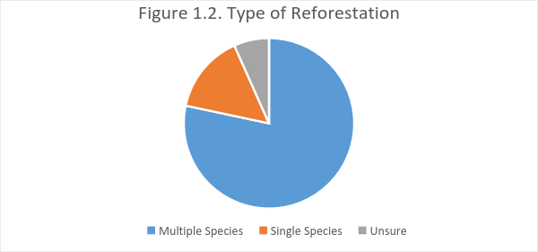

With regards to whether forests should be self-sustaining and should not need human intervention, 29 (48%) agreed that forests should be self-sustaining, 16 (27%) disagreed, and 15 (25%) of the respondents were unsure as shown in Figure 1.3. This data tells the group that more the respondents were divided as according to their understating of what a self-sustaining forest is. Others discussed that these forests should be able to maintain themselves in the long run but should still be monitored from time to time. While others discussed that the process of reforestation itself contradicts this question as reforestation involves the intervention of humans.

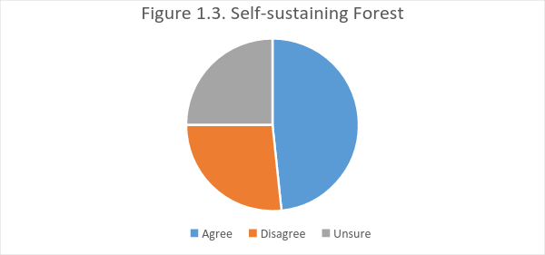

Majority of the respondents agreed that the following factors as shown in Figure 1.4 as the most difficult things to consider and do during a reforestation project suggesting that majority of the tasks/processes of reforestation are considered as troublesome or at least requires a significant amount of effort.

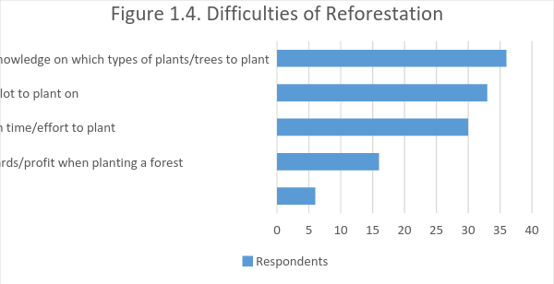

The respondents have also defined which of the following factors, as shown in Figure 1.5, would best motivate them to plant in the future. Disregarding the subjective option of “the feeling of helping Mother Nature”, the “Hassle-free maintenance” can be considered as the most effective motivation, further emphasizing the hassle and difficulty of reforestation.

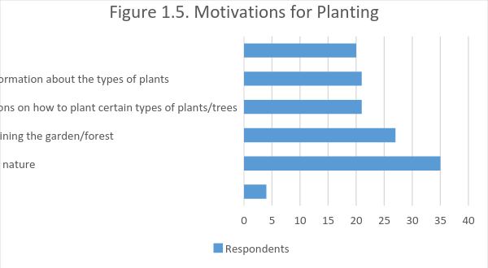

As for the respondent’s opinion on how useful or practical the group’s proposed application will be, majority agreed on its effectiveness as shown in Figure 1.6 as according to the group’s brief discussion of the proposed solution.

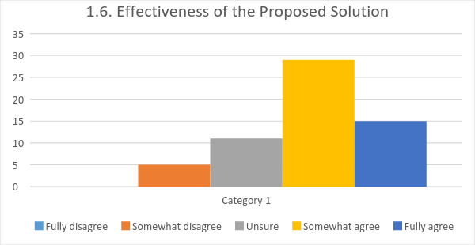

The agricultural expert stated different concepts pertaining to how a forest would remain sustainable and it is best designed. In order to keep a forest sustainable, varying species should be planted so that each plant would be able to use each other for their own advantage, for example: smaller plants who require shade may be shaded by the larger plants which provide shade. At the same time, shrubs or vines that need a tall tree for protection provide nutrients that a tree would need. In an ideal forest, there is a give and take environment.

To properly design an ideal forest, taller trees are placed at the northern side while smaller trees would be on the southern side. According to the agricultural expert, the design as mentioned before would allow all the trees to get proper sunlight, and that there will be no trees that are left out.

Another important design pattern to follow is the planting of trees, the tallest tree would be planted at the north, and there would be vines crawling on its trunk as well as root crops that benefit from the tree's shade. Next is the shorter trees which is a little bit south of the taller tree. After that, the shrub would be next, then the herbs, then finally, the root vegetables. Again, this follows the pattern of the planting taller trees at the north while the shorter trees are planted at the south. The agriculture expert focused on these key points as this is how he does his forest gardening or forest planning.

Given that trees in a forest should optimally have the tallest ones in the north and the shortest ones in the south to equally distribute the amount of sunlight to each of the elements inside the forest. The proposed solution of the group in order to get the optimal placement of forest elements inside a forest is to make use of an algorithm that is based on the solution for the stable marriage algorithm to pair up different species of trees to their optimal position in the forest considering their height and shade tolerance. This allows us to place trees in such a way that each element in the forest gets the adequate amount of sunlight that it needs for their growth.

The agricultural expert also gave us his dreams and aspirations as to what the group proposed application would potentially be, and he fervently hopes that the group would be able turn it into a game sometime in the future, so that the application would be more interactive, and people will be enticed to use it.

However, due to time constraints, it was not possible for the group to develop the envisioned game. Instead, the group developed a simple Java application that prompts the user to enter the types of plants that he/she would like to be planted in the given plot of land along with the information about their height and shade tolerance which would be used as the basis in placing them in the most optimal placement.

Using the algorithm discussed earlier and the data that was gathered as a reference, the program the group have developed would gradually place the plants starting from the left and moving to the right for each iteration until the entire plot is covered taking into consideration, the plants that was planted in the last iteration in order to avoid planting the same plants again and again to promote biodiversity.

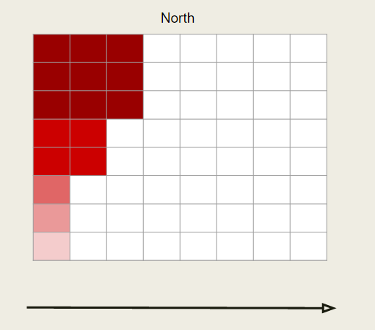

**Figure 2.1. The visual representation of the algorithm.**

The elements in the forest are divided into 3 categories based on their height: tall, medium and short. Tall elements occupy 3x3 space in the map while shorter elements occupy only 1 tile. Medium sized elements on the other hand, occupy 2x2 tiles in the map.

Taking into consideration that the tiles in the northern portion of the map prefers to be paired with taller and sun demanding trees while tiles in the southern portion of the map prefers to be paired with shorter ones, the program would iterate through all the tiles in the map starting from the top-left tile iterating column per column. For each iteration, the program would then pair up the tile with its most preferred species of tree coming from the list of trees entered by the user. In addition, the program also checks the nearby trees if they are of the same species in order to avoid planting the same species of trees adjacently in order to promote biodiversity.

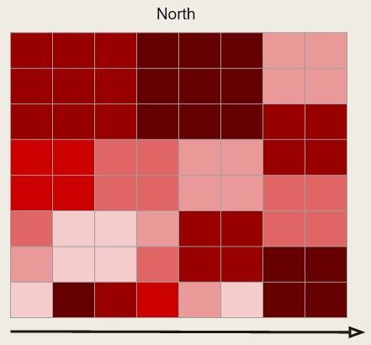

**Figure 2.2. A sample output using the algorithm**

The resulting plot of land would show the optimal placing of forest elements given the set of plants that was given the used which would then be displayed by our program for possible agricultural and environmental purposes to make sure that the planted trees would thrive by getting adequate amount of sunlight.

1. **CONCLUSION**

Overall, the results from the surveys provided the group enough information to conclude that the overall process of reforestation is considered as an inconvenience for common people who are not dedicated to the field of reforestation/agriculture and that majority would not even consider planting, even on a small scale (such as on a home garden or small lot) if the difficulty of maintaining the garden is present.

As such, the group focused on creating a solution that would aid in the data gathering/ research phase of the reforestation process that provides information about how the elements in the forest could be placed in a way that sunlight is distributed properly on each of the elements inside the forest, which according to the interviewed agricultural expert was effective and helpful due to the fact the it saves them time and effort on research about the optimal placement of the elements inside the forest and allows them to focus on other tasks in hand such as planting and taking cares of the trees themselves.

The group believes that the research topic can be approached through various means depending on the research group’s background, knowledge base, and experience. The main reason why the group has developed an application as a means for solving the problem statement is due to the group’s experience in developing applications as means for solving other problems. If other research groups plan on tackling this topic, they may have varying solutions depending on their specialization. For example: students studying agriculture may focus on the changing the process of reforestation itself; students studying business may focus on the process of acquiring trees or greenery to be planted; etc. In order to contribute varying related studies and diversify the research of the topic overall, the group recommends others to approach the problem from their own viewpoints and propose solutions accordingly.

1. **REFERENCES**

[1] Asio, V. B. (1995). Genesis and degradation of soils under different land uses. In: Leyte, Philippines. ViSCA-GTZ Ecology Program, preliminary results of Ph.D. thesis, University of Hohenheim, Inst. Bodenkunde.

[2] Goltenboth, F. (1999). Rainforestation Planting – an innovative approach for sustainable land use and biodiversity conservation in the Philippine ecosystems, 3-16.

[3] Holmgren, D. and Mollison, B. (2011). Introduction to Permaculture. Pamphlet I in the Permaculture Design Course Series, 3.

[4] Hutter, C., Goltenboth F., and Milan, P.P. (2003). Paths to sustainable development – New experiences in the Philippines. Euronatur Edition Vol. 1, 83.

[5] Milan P.P (2009). Rainforestation Farming – A farmer’s guide to sustainable forest biodiversity management, 2.

[6] Milan, P.P. and Calomot, N.H. (1994). Biodiversity conservation for sustainable island development through community participation, 12.

[7] Milan, P.P. and Margraf, J. (1994). Rainforestation farming, an alternative to conventional concepts, 12.

[8] Peters, Bert (2016, July 6). President of Philippine Permaculture Association. Personal Interview.

[9] Schulte, A. (2002). Rainforestation Farming: Option for rural development and biodiversity conservation in the humid tropics of Southeast Asia., Shaer Verlag, Aechen, Germany.

1. **Appendix A: Survey Questions**
2. Are you a student or a homeowner? (Student/Homeowner/Other)
3. Do you have any background whatsoever in agriculture? (Yes/A little/None at all)
4. If yes, do you have any experience planting greenery/a garden/a tree? (Yes/No)
5. Are you aware that deforestation is a major problem in today’s society? (Yes/No/Unsure)
6. Do you think reforestation an effective way to address the problem? (Yes/No/Unsure)
7. Which kind of reforestation method do you think is much more effective? (Single species/Multiple species/Unsure)
8. Do you agree that forests should be self-sustaining and should not need human intervention? (Yes/No/Unsure)
9. Which do you feel is/are the most difficult thing(s) to do during reforestation?
10. Getting prior knowledge on which types of plants/trees to plant
11. Finding a good lot to plant on
12. Takes too much time/effort to plant
13. Not much rewards/profit when planting a forest
14. Others
15. What would encourage you to plant?
16. Rewards/profit after planting
17. Easily accessible source of information about the types of plants
18. Easy to understand instructions on how to plant certain types of plants/trees
19. Hassle-free process of maintaining the garden/forest
20. The feeling of helping mother nature
21. Others
22. How useful would you rate the proposed application for planting gardens/forests? (1-5; with 1 being fully disagree and 5 being fully agree)
23. Do you have any other suggestions or ideas for fighting against deforestation?
24. Do you have any other suggestions or ideas for improving the current process of reforestation?
25. General comments or suggestions about the proposed application?
26. **Appendix B: Permaculture Experts Interview Questions**
27. What do you take note of when given a barren land to plant on?
28. How long does it usually take to create an effective food forest?
29. What guidelines do you follow when planning for creating a food forest?
30. Given the 7 levels of the forest in forestry, which plants/trees should be planted first?
31. Is there a fixed amount of distance or number of plants/trees when planting a forest?
32. Are there placement hierarchies or specific locations/distances to be followed when planting certain plants and/or trees together?
33. What are the steps taken when planting?
34. Are there sequences to be followed when planting trees?
35. Where can we find existing information about the status of current forests in the world?
36. Do you have any other suggestions or ideas for fighting against deforestation?
37. Do you have any other suggestions or ideas for improving the current process of reforestation?
38. General comments or suggestions about the proposed application?